**23MX18 Web Application Development**

**HTML Exercises**

**Exercise 1**

**Layout using <table>**

Here is an example of the use of an HTML table for laying out part of a webpage.

|  |  |  |
| --- | --- | --- |
|  |  |  |
|  | |

<table width = "300">

<tr>

<td bgcolor = "blue" width = "100" rowspan = "2">

<td bgcolor = "yellow" width = "100" height = "150">

<td bgcolor = "red" width = "100" height = "150">

</tr>

<tr>

<td bgcolor = "green" height = 50 colspan = 2>

</tr>

</table>

**Exercise 2**

Create the following table using HTML <table>

|  |  |  |
| --- | --- | --- |
| **Column 1** | **Column 2** | **Column 3** |
| A numbered list:   1. Able 2. Baker 3. Charlie 4. Delta 5. Echo | B | C |
| An unnumbered list:   * Pounds * Dollars * Euro * Yen * Roubles | |

**Exercise 3**

## Colors

Create a Web page like the screenshot:

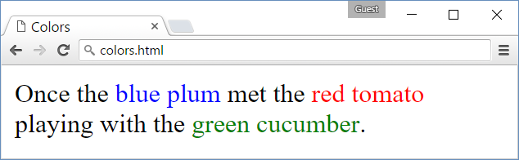

### Hints

* Use a paragraph **<p>…</p>** to hold the text.
* Use <span style="…">text</span> for the colored text

**Exercise 4**

## Rectangles

Create a Web page like the screenshot:

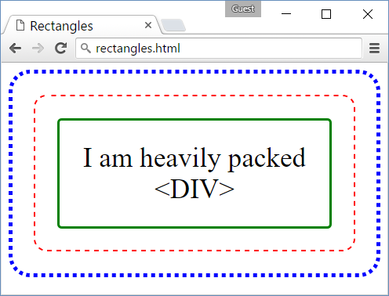

### Hints

* Use 3 nested <div> elements
* **Outside div**: blue dotted border + border-radius + padding
* **Middle div**: red dashed border + border-radius + padding
* **Inner div**: green solid border + border-radius + padding + text-align + font-size
* Use &lt; and &gt; to escape the < and > characters in the text…